20210727 Kogei List
27 July 2021

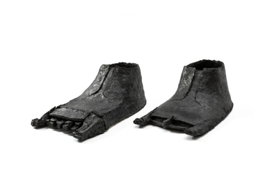 | Keiji Ito 1935-present  仏足（一組）, 2017  Ceramic  H5 1/2 x W7 5/8 x D14 5/8 in  H14 x W19.5 x D37 cm  H5 1/2 x W7 5/8 x D15 1/4 in  H14 x W19.5 x D38.8 cm  (C17047AP) | ¥ 600,000.00
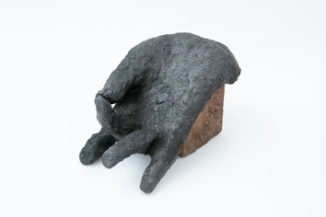 | Keiji Ito 1935-present  仏手, 2018  Ceramic  H4 x W3 3/4 x D8 1/8 in  H10.5 x W9.6 x D20.6 cm  (C19968AP)
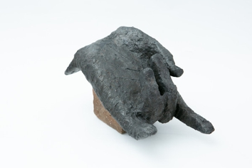 | Keiji Ito 1935-present  仏手, 2019  Ceramic  H4 3/8 x W4 1/4 x D8 1/4 in  H11.2 x W10.8 x D21 cm  (C19969AP)
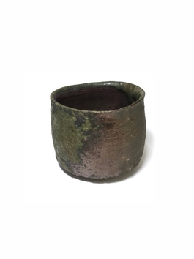 | Kai Tsujimura 1976-present  備前ぐい呑  Ceramic  H2 1/8 x W2 5/8 x D2 5/8 in  H5.5 x W6.7 x D6.7 cm  (C20352P) | ¥ 12,000.00
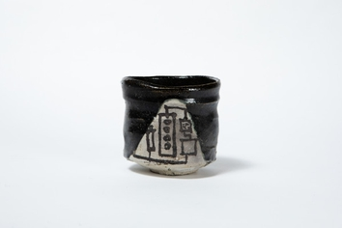 | Kai Tsujimura 1976-present  織部黒茶碗  Ceramic  H4 1/8 x W4 1/8 x D4 1/8 in  H10.5 x W10.5 x D10.5 cm  (C21666) | ¥ 120,000.00
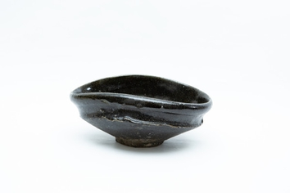 | Kai Tsujimura 1976-present  織部黒茶碗  Ceramic  H2 7/8 x W6 7/8 x D5 3/8 in  H7.2 x W17.5 x D13.6 cm  (C21668) | ¥ 120,000.00
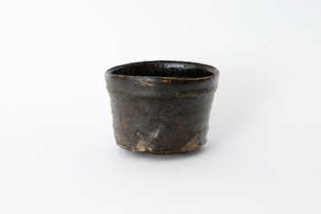 | Kai Tsujimura  織部茶碗  Ceramic  H3 1/4 x W4 1/2 x D4 1/8 in  H8.3 x W11.5 x D10.3 cm  (C16788P) | ¥ 100,000.00
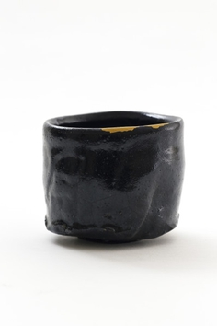 | Shiro Tsujimura 1947-Present  Devon Kuro Chawan  Yes  Ceramic  H3 3/4 x W 4 1/4 in, H9.53 x W10.8 cm  (C19678) | $ 5,500.00
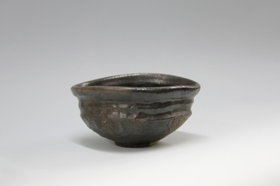 | Shiro Tsujimura 1947-Present  Black Tea Bowl, Oribe Style  Yes  Ceramic  H3 1/4 x W6 1/2 in, H8 x W16.4 cm  (C15240) | $ 5,500.00
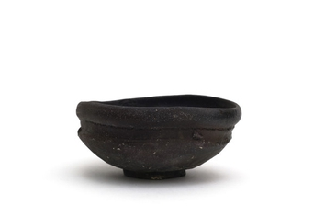 | Shiro Tsujimura 1947-Present  Black Oribe Tea Bowl, 2018  Yes  Ceramic  H2 3/4 x W6 2/4 x L5 3/4 in, H6.9 x W16.5 x L14.6 cm  (C17600) | $ 5,500.00
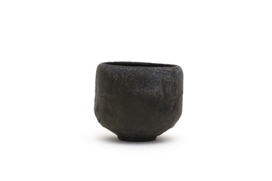 | Shiro Tsujimura 1947-Present  黒茶碗 Black Tea Bowl, 2018  Yes  Ceramic  H3 3/4 w W4 1/2 in, H9.1 x W10.4 cm  (C17601) | ¥ 500,000.00
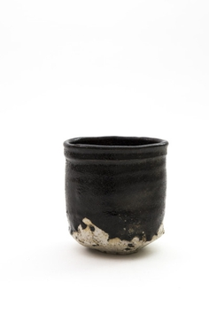 | Shiro Tsujimura 1947-Present  Black Oribe Tea Bowl  Yes  Ceramic  H4 3/4 x W4 2/4 x L3 3/4 in, H12.1 x W11.4 x L9.5cm  (C19740) | $ 5,500.00
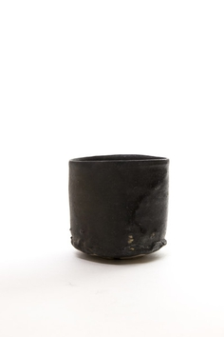 | Shiro Tsujimura 1947-Present  Hikidashi Kuro Chawan  Yes  Ceramic  H3 3/4 x W4 1/4 xL 3 3/4 in, H9.5 x W10.8 x L9.53 cm  (C19742) | $ 5,500.00
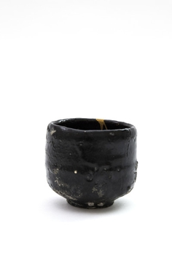 | Shiro Tsujimura  Black Tea Bowl  Ceramic, Gold (Kintsugi)  H3 3/4 x W4 1/4 in, H9.6 x W10.8 cm  (C19743) | $ 5,500.00
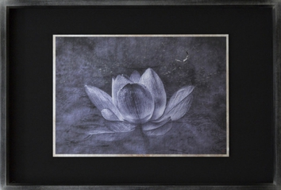 | Kenji Wakasugi 1941-present  仏印  Photography  H19 1/2 x W28 3/8 in  H49.5 x W72 cm  (A17759) | ¥ 370,000.00
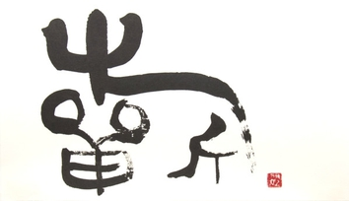 | Suikei Saito 1988 -present  「祈-1」（金文書体), 2015  Calligraphy  H5 5/8 x W9 3/4 in  H14.2 x W24.9 cm  (A14665)
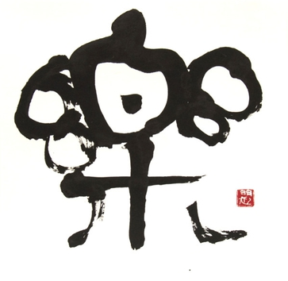 | Suikei Saito 1988 -present  「楽-1」（金文書体）, 2015  Calligraphy  H6 1/2 x W6 3/4 in  H16.4 x W17cm  (A14678)
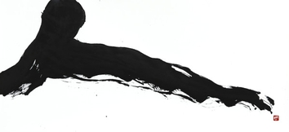 | Suikei Saito  "Hito" (Human)  Calligraphy  H15 3/4 x W34 1/4 in, H40 x W87cm  (A14573)
Suikei Saito
"Kai"
Calligraphy
H29 3/4 x W36 7/16 in, H75.5 x W92.5 cm
(A14766)
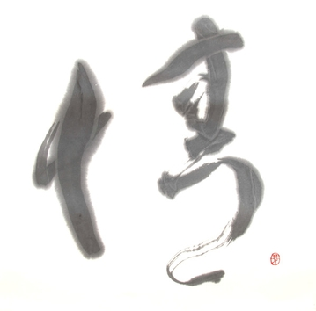 | Suikei Saito  "Jyou" (Emotion)  Calligraphy  H14 3/4 x W15 1/4 in, H37.5 x W38.8 cm  (With Frame) H51 x 17 9/16 in, H129.5 x W44.6 cm  (A14660)
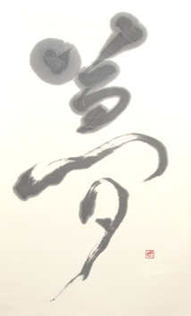 | Suikei Saito  "Yume" (Dream)  Calligraphy  H23 1/4 x W14 in, H59 x W35.5cm  (A14666)
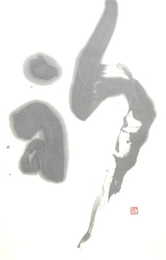 | Suikei Saito  "Inori" (Prayer)  Calligraphy  H5 1/4 x W10 3/16 in, H13.3 x W25.9 cm  (A14668)
Suikei Saito
"Umi" (Ocean)
Calligraphy
H50 x W17 1/8 in, H127 x W43.5 cm
(A15780)
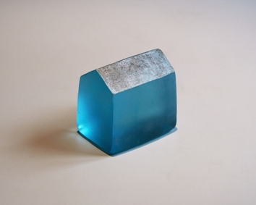 | Katsuya Ohgita  House  Glass  H3 1/8 x W2 1/2 x D3 3/8 in  H8 x W6.2 x D8.5 cm  (B20972NP) | $ 750.00
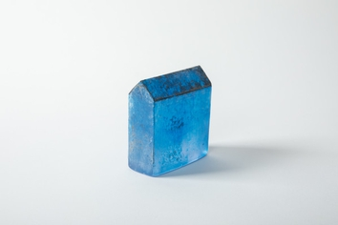 | Katsuya Ohgita 1957-present  HOUSE BP ﾌﾞﾙｰ（薄形）  Glass  H3 1/4 x W3 3/8 x D1 1/4 in  H8.2 x W8.5 x D3.2 cm  (B22830K) | ¥ 30,000.00
 | Hideo Kageyama 1956-Present  Noren (Winter Mt.Fuji)  Textile  (F8090P) | $ 975.00
 | Hideo Kageyama 1956-Present  Noren (Rain) with Hemp  Textile  (F10611P) | $ 810.00
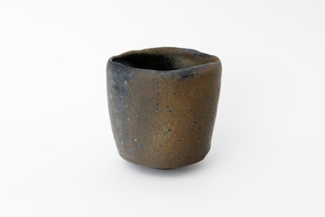 | Hiroshi Goseki 1988-present  Blue Yohen Black Tea Bowl  Ceramic  H4 1/2 x W4 3/8 x D4 3/8 in  H11.5 x W11 x D11 cm  (C22801) | $ 1,600.00
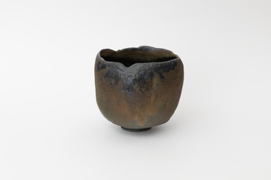 | Hiroshi Goseki 1988-present  Blue Yohen Tea Bowl  Ceramic  H4 3/8 x W4 5/8 x D5 in  H11 x W11.6 x D12.6 cm  (C22805) | $ 1,360.00
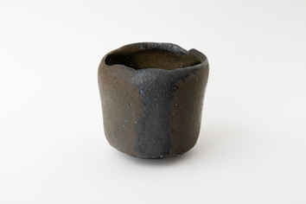 | Hiroshi Goseki 1988-present  Blue Yohen Tea Bowl  Ceramic  H4 1/8 x W4 3/8 x D4 3/8 in  H10.2 x W11 x D11 cm  (C22806) | $ 1,600.00
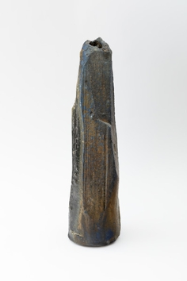 | Hiroshi Goseki 1988-present  Blue Yohen Vase  Ceramic  H13 3/8 x W3 1/2 x D4 3/8 in  H34 x W9 x D11 cm  (C22811) | $ 1,600.00
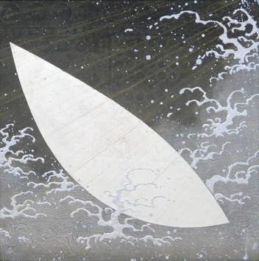 | Ken Matsubara  Moon Wave 月濤  Paint  H28 3/4 x W28 3/4 in  H73 x W73 cm  (A21176) | ¥ 640,000.00
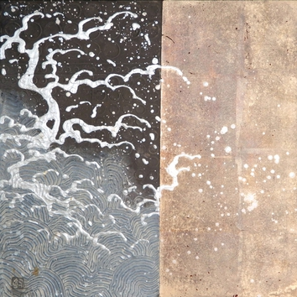 | Ken Matsubara  Waves Crashing II 瀾  Paint  H17 3/4 x W17 3/4 in  H45 x W45 cm  (A21182) | ¥ 300,000.00
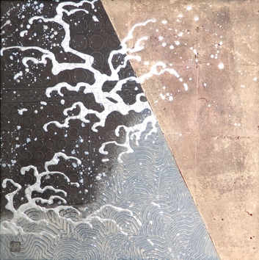 | Ken Matsubara  Waves Crashing III 瀾  Paint  H17 3/4 x W17 3/4 in  H45 x W45 cm  (A21183) | ¥ 300,000.00
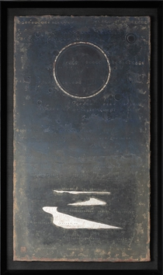 | Ken Matsubara 1948-present  盈, 2020  Painting  H40 1/2 x W23 7/8 in  額 H103 x W60.5 cm  (A21334) | ¥ 640,000.00
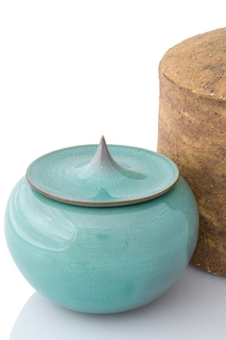 | Shinobu Kawase  Celadon Incense Burner  Ceramic  H3 1/8 x W3 3/4 x D3 3/4 in  H8 x W9.5 x D9.5 cm  (C18775NP) | $ 7,500.00
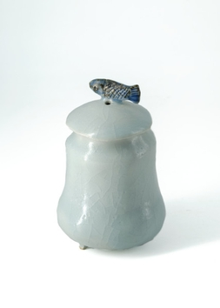 | Shin Fujihira 1922-2012  Fish Incense Burner, 2008  Ceramic  H4 x 1/2 x W2 3/4in H11 x W7cm  (C2364) | $ 4,300.00
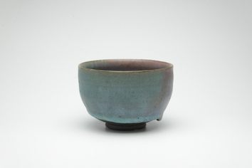 | Shin Fujihira 1922-2012  Cinnabar Tea Bowl, 1980  Ceramic  H3 x W4 1/2in H8 x W12cm  (C19495) | $ 7,800.00
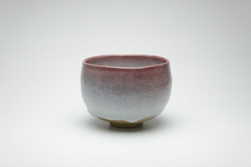 | Shin Fujihira 1922-2012  Cinnabar Tea Bowl, 1993  Ceramic  H3 3/4 W5 3/4in H10 W14cm  (C19510) | $ 9,600.00
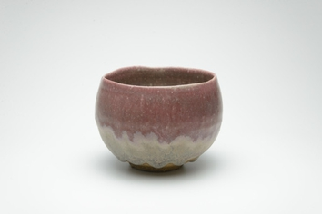 | Shin Fujihira 1922-2012  Cinnabar Tea Bowl, 1993  Ceramic  H3 3/4 x W4 3/4 x L4 3/4in  H9 1/2 x W12 1/2 x L12 1/2cm  (C19517) | $ 9,300.00
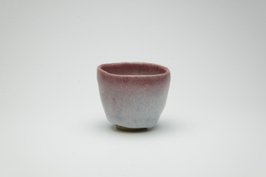 | Shin Fujihira 1922-2012  Cinnabar Cup, 1990  Ceramic  H2 2/4 x W2 3/4 x L2 3/4in  H6 x W6 1/2 x L6 1/2cm  (C19532) | $ 1,800.00
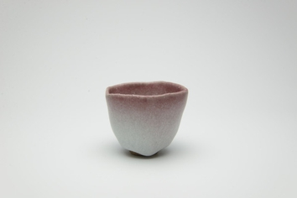 | Shin Fujihira 1922-2012  Cinnabar Cup, 1990  Ceramic  H1 3/4 x W2 3/4 x L2 3/4in  H5 x W6 1/2 x L6 1/2cm  (C19533) | $ 1,800.00
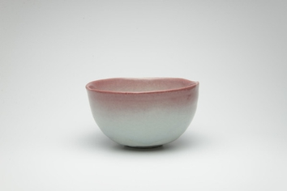 | Shin Fujihira 1922-2012  辰砂茶盌  Ceramic  H3 1/8 x W5 1/2 x D5 1/2 in  H8 x W14 x D14 cm  (C19519) | $ 9,300.00
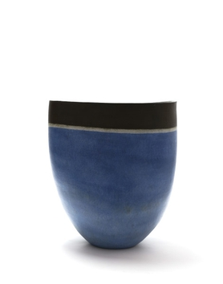 | Mitsukuni Misaki 1951-present  Saiyuudeiki, 2017  Ceramic  H20 1/2 x W18 1/2 x L12 1/4in,  H51 1/2 x W47 x L31cm  (C17006) | $ 13,500.00
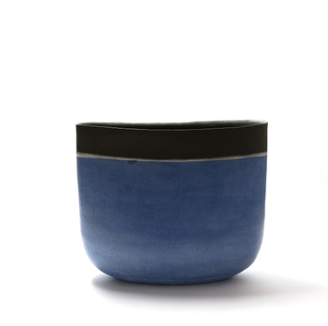 | Mitsukuni Misaki 1951-present  Saiyuudeiki, 2017  Ceramic  H20 1/2 x W23 3/4 x L10 3/4in,  H51 1/2 x W60 x L27cm  (C17005) | $ 18,000.00
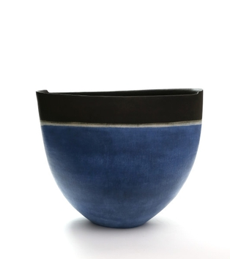 | Mitsukuni Misaki 1951-present  Saiyuudeiki, 2017  Ceramic  H18 3/4 x W22 3/4 x L9 1/2in,  H48 x W58 x L24cm  (C16969) | $ 15,600.00
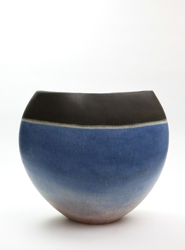 | Mitsukuni Misaki 1951-present  Saiyuudeiki, 2017  Ceramic  H19 1/2 x W21 3/4 x L9 1/4in,  H49 x W55 x L23cm  (C16970) | $ 15,600.00
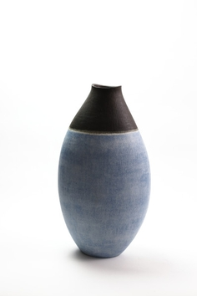 | Mitsukuni Misaki 1951-present  Saiyuudeiki, 2017  Ceramic  H25 1/4 x W12 3/4 x L9 1/4in,  H64 x W32 x L23cm  (C16855) | $ 15,600.00
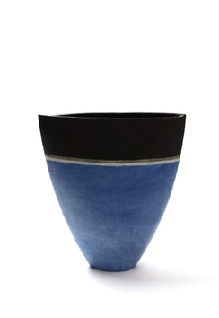 | Mitsukuni Misaki 1951-present  Saiyuudeiki, 2017  Ceramic  H19 1/2 x W16 3/4 x L6 3/4in,  H49 x W43 x L17cm  (C16856) | $ 9,500.00
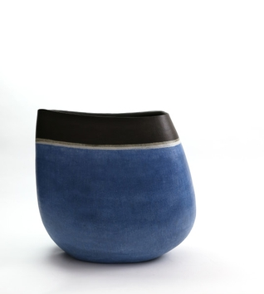 | Mitsukuni Misaki 1951-present  Saiyuudeiki, 2017  Ceramic  H20 1/2 x W22 1/2 x L13 1/2in,  H52 x W57 x L34cm  (C16853)
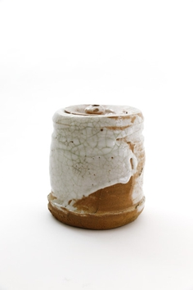 | Kai Tsujimura 1976-Present  Shino Water Jar, 2019  Ceramic  H8 1/2 x W7 3/4in H21.2 x W19.4cm  (C19631P) | $ 2,000.00
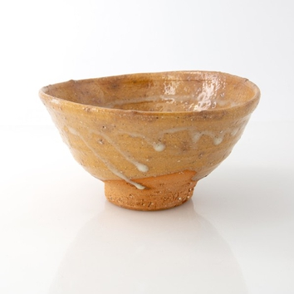 | Kai Tsujimura 1976-Present  Karatsu Tea Bowl  Ceramic  H2 3/4 x W5 1/2 x L5 3/4in H6.8 x W13 1/2 x L14.8cm  (C19627) | $ 1,480.00
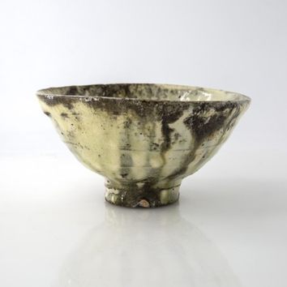 | Kai Tsujimura 1976-Present  Kohiki Tea Bowl  Ceramic  H3 1/4 x W5 3/4in H8.1 x W14.3cm  (C19387) | $ 1,500.00
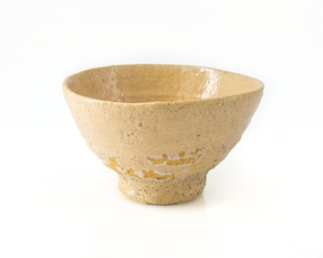 | Kai Tsujimura 1976-Present  Ido Cup  Ceramic  (C9368P) | $ 90.00
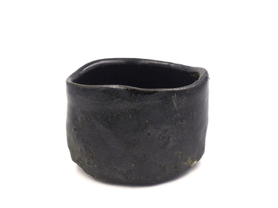 | Kai Tsujimura 1976-Present  Hikidashi Kuro Tea Bowl  Ceramic  H3 1/4 x W4 3/4 in, H8.2 x W12 cm  (C11500AP) | $ 1,500.00
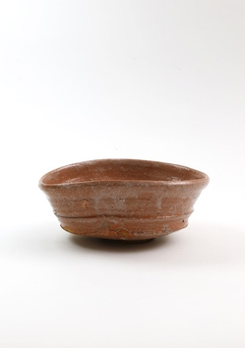 | Kai Tsujimura 1976-Present  Karatsu Dish  Ceramic  H4 1/8 x W9 5/8 x L8 1/4 in, H10.6 x W24.5 x D21 cm  (C16441NP) | $ 300.00
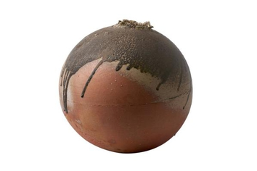 | Shiro Tsujimura 1947-Present  Sphere Shaped Jar, Natural Ash Glaze, 2017  Yes  Ceramic  H15 3/4 x W17 1/4 x L16 3/4 in, H40 x W43.8 x L42.6 cm  (C18398) | $ 18,000.00
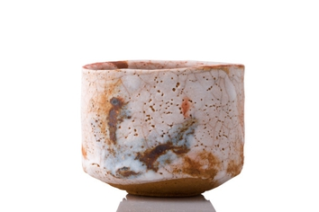 | Shiro Tsujimura 1947-Present  Shino Tea Bowl  Yes  Ceramic  H3 3/4 x W5 x L4 1/2 in, H9.5 x W12.5 x L11.2 cm  (C8585) | $ 5,500.00
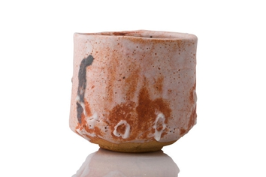 | Shiro Tsujimura 1947-Present  Red Shino Tea Bowl  Yes  Ceramic  H4 x W4 3/4 in, H10 x W12 cm  (C10401) | $ 5,500.00
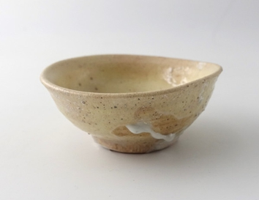 | Shiro Tsujimura 1947-Present  Ido Sake Cup  Yes  Ceramic  H1 1/2 x W3 1/4 x L3 1/4 in, H3.2 x W8.2 x L7.7 cm  (C17132) | $ 500.00
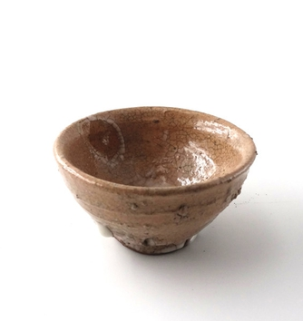 | Shiro Tsujimura 1947-Present  Ido Sake Cup, 2017  Yes  Ceramic  H1 1/2 x W3 in, H3.8 x W7.2 cm  (C17131) | $ 500.00
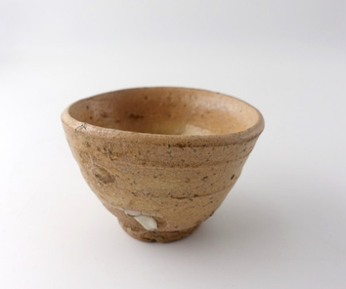 | Shiro Tsujimura 1947-Present  Ido Sake Cup, 2016  Yes  Ceramic  H5 x W3 in, H4.8 x W7.5 cm  (C15254) | $ 500.00
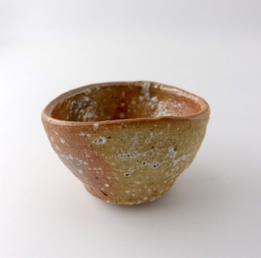 | Shiro Tsujimura 1947-Present  Shigaraki Sake Cup  Yes  Ceramic  H2 x W3 in, H4.7 x W7.4cm  (C10923) | $ 500.00
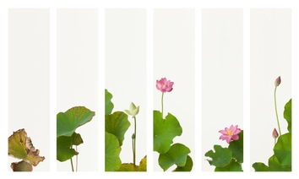 | Takashi Tomo-oka 1971-present  Lotus Byobu Screens (set of 6), Hasu-Byoubu, 2013  Yes  Photography  H11 x W43 1/8 in, H28 x W109.6 cm  Edition of 15  (n10_0069) | $ 6,000.00
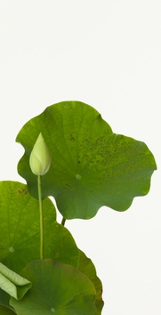 | Takashi Tomo-oka 1971-present  Tathata Lotus 2, Shinnyoren, 2013  Yes  Photography  H23 1/8 x W11 13/16 in, H58.8 x W30 cm  Edition of 15  (n10_0081) | $ 1,300.00
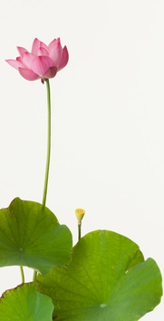 | Takashi Tomo-oka 1971-present  Pink Lotus 2, Oren, 2013  Yes  Photography  H23 1/8 x W11 13/16 in, H58.8 x W30 cm  (n10_0082) | $ 1,360.00
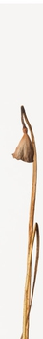 | Takashi Tomo-oka 1971-present  Dried Lotus 1, Karehasu, 2014  Yes  Photography  H36 7/16 x W4 5/8 in, H92.6 × W11.8 cm  (n10_0094)
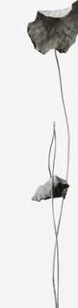 | Takashi Tomo-oka 1971-present  Dried Lotus 2, Karehasu, 2014  Yes  Photography  H28 x W7 3/16 in, H71.1 × W18.2 cm  Edition of 15  (n10_0095) | $ 1,000.00
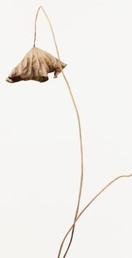 | Takashi Tomo-oka 1971-present  Dried Lotus 3, Karehasu, 2014  Yes  Photography  H23 1/8 x W11 13/16 in, H58.8 x W30 cm  (n10_0096)
Takashi Tomo-oka 1971-present
Lotus Seed 2, Hasu-no-mi, 2014
Yes
Photography
H36 7/16 x W4 5/8 in, H92.6 × W11.8 cm
(n10_0118)
Takashi Tomo-oka 1971-present
Dried Lotus 4, Karehasu, 2014
Yes
Photography
H36 7/16 x W6 1/8 in, H92.6 × W15.5 cm
(n10_0119)
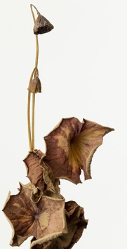 | Takashi Tomo-oka 1971-present  Dried Lotus 5, Karehasu, 2017  Yes  Photography  H30 1/2 x W15 9/16 in, H77.5 × W39.6 cm  Edition of 15  (n10_0175) | $ 1,300.00
Takashi Tomo-oka 1971-Present
Lotus
Photography
(A10326)
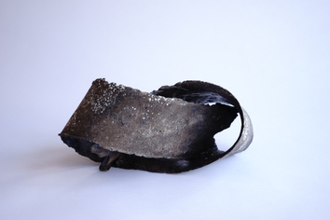 | Yukiya Izumita 1966-present  Yui Knot, 2017  Ceramic  H6 x W12 x L6 in  H15 x W30 x L15 cm  (C16526) | $ 1,650.00
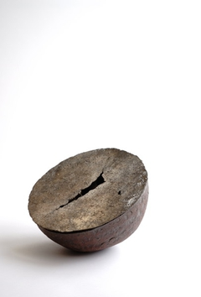 | Yukiya Izumita 1966-present  Henko Pot, 2017  Ceramic  H9 2/4 x W12 x L12 in  H24 x W30 x L30 cm  (C16516) | $ 4,000.00
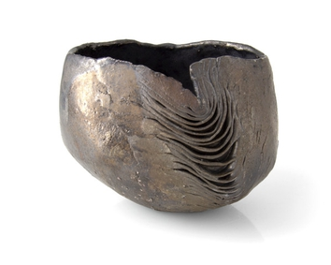 | Yukiya Izumita 1966-present  Sekisoh Tea Bowl, 2019  Ceramic  H3 3/4 x W4 3/4 x L3 3/4in  H9.8 x W12.3 x L10cm  (C20192) | $ 2,300.00
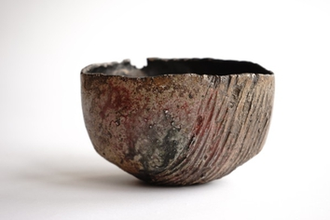 | Yukiya Izumita 1966-present  Flake Tea Bowl, 2019  Ceramic  H3 3/4 x W5 3/4 x L4 2/4in  H9 1/2 x W14 1/2 x L11 cm  (C20392) | $ 2,300.00
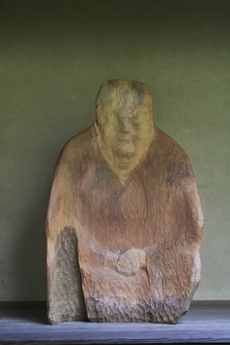 | Sho Kishino  Seated, 2019  Cypress (asunaro) lumber sourced from a shrine in Keihoku, Kyoto  H47 ⅕ x W47 ⅕ x D23 ⅗ in  H120 x W120 x D60 cm  (B21412) | $ 25,000.00
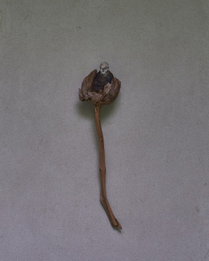 | Sho Kishino  Seated  Fallen pine tree  H17 x W4 3/10 x D4 1/2 in  H43 x W11 x D11 1/2 cm  (B21422) | $ 2,400.00
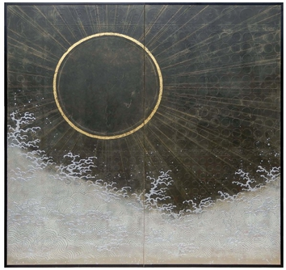 | Ken Matsubara 1948-present  Sun & Moon, 2020  Painting  Each Panel is  H48 1/4 x W48 1/4 x D.79 in,  H122 x W122 x D2 cm  (A21331) | $ 40,000.00
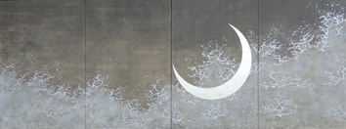 | Ken Matsubara 1948-present  Kukai's View; Sun and Moon, Crescent Moon, 2017  Painting  H71 x W187 x D.79 in,  H180 × W475 x D2 cm  (Set of 4 panels)  (A19964) | $ 100,000.00
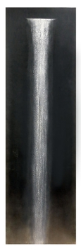 | Ken Matsubara 1948-present  Scenery, 2016  Painting  H63 1/2 x W17 3/4 in,  H161 x W45 1/2 cm  (A14959) | $ 15,000.00
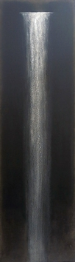 | Ken Matsubara 1948-present  Scenery, 2016  Painting  H63 1/2 x W17 3/4 in,  H161 x W45 cm  (A14957) | $ 15,000.00
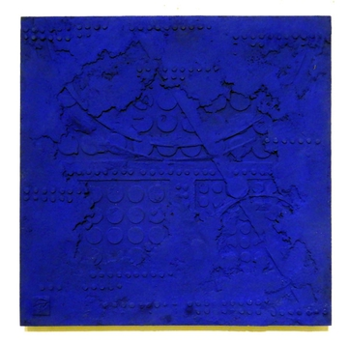 | Ken Matsubara  TAMAYURA Ⅲ  Painting  17 3/4 x 17 3/4 in  45 x 45 cm  (A19994) | $ 5,500.00
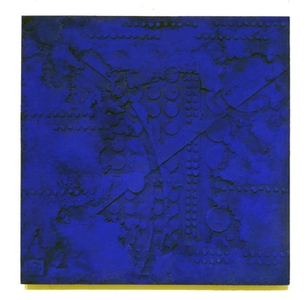 | Ken Matsubara  TAMAYURA Ⅱ  Painting  16 3/4 x 17 3/4 in  42.5 x 45 cm  (A19993) | $ 5,500.00
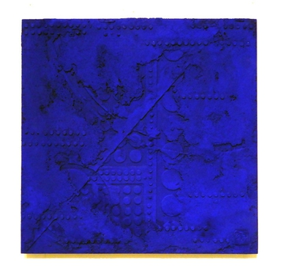 | Ken Matsubara  TAMAYURA Ⅰ  Painting  15 3/4 x 17 3/4 in  40 x 45 cm  (A19992) | $ 5,500.00
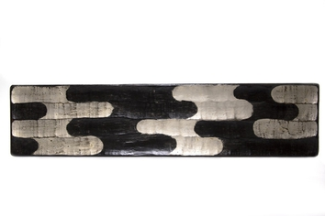 | Tohru Matsuzaki 1944-present  Tray, 2012  Lacquer  H1 x W27 1/4 x L2 3/4 in,  H2 1/2 x W69 x L6 1/2 cm  (C18333) | $ 2,000.00
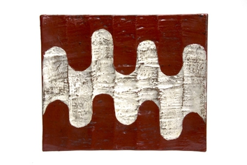 | Tohru Matsuzaki 1944-present  Tray with Legs  Lacquer  H1 3/4 x W11 1/2 x L9 1/2 in,  H4 x W29 x L24 cm  (C18335) | $ 2,340.00
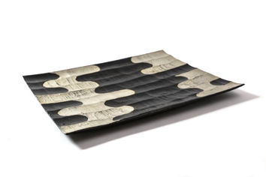 | Tohru Matsuzaki 1944-present  Tray, 2017  Lacquer  H2 3/4 x W6 1/2 x L5 1/2 in,  H7 x W16.5 x L14 cm  (C16879) | $ 4,800.00
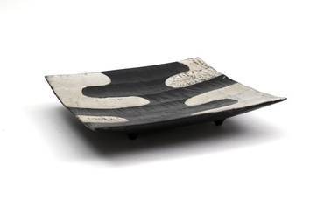 | Tohru Matsuzaki 1944-present  Ridged Tray with Legs, 2017  Lacquer  H3/4 x W9 1/2in,  H2 1/2 x W24 cm  (C17170) | $ 2,340.00
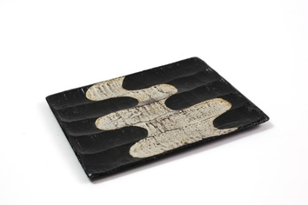 | Tohru Matsuzaki 1944-present  Ridged Tray, 2017  Lacquer  H1/2 x W9 3/4 x L7 3/4in,  H1 1/10 x W25 1/5 x L20 1/5 cm  (C17171) | $ 910.00
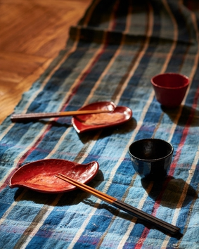 | Tohru Matsuzaki 1944-present  Plate with Flower Motifs  Yes  Lacquer  (C5484) | $ 250.00
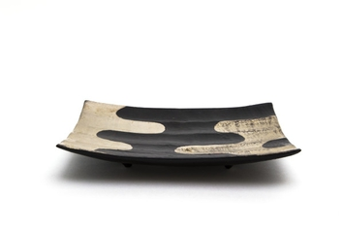 | Tohru Matsuzaki 1944-present  Lacquer Plate  Yes  Lacquer  H1 3/4 x W10 9/16 x L8 in, H4.5 × W26.9 × D20.3 cm  (C18327) | $ 2,340.00
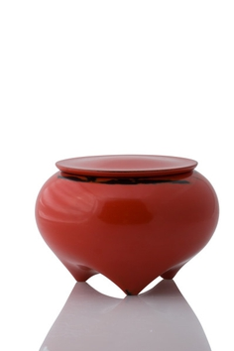 | Jihei Murase 1957-present  Negoro-Nuri Tea Caddy, 2018  Lacquer  H2 3/5 x W1 3/10 in, H6 1/2 x W3 1/5 cm  (C18387) | $ 5,000.00
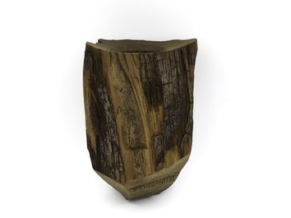 | Jihei Murase 1957-present  Ancient Zelkova Hanging Vase, 2015  Lacquer  H8 x W5 1/4 x L4 1/4 in,  H19 4/5 x W13 1/5 x L10 1/5 cm  (C14779) | $ 3,150.00
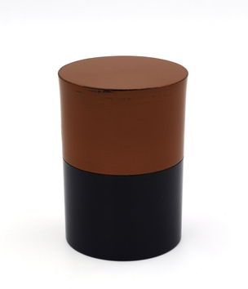 | Jihei Murase 1957-present  Negoro Tea Caddy, 2016  Lacquer  H3 1/4 x W2 1/4 in,  H8 x W5 3/5 cm  (C15727) | $ 3,600.00
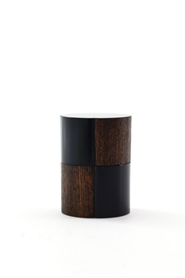 | Jihei Murase 1957-present  Checkered Tea Caddy, 2017  Lacquer  H3 1/2 x W2 1/2 in,  H8 3/10 x W6 1/10 cm  (C17030) | $ 4,800.00
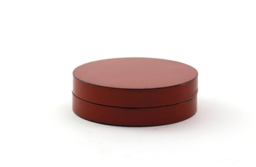 | Jihei Murase 1957-present  Ichimonji Incense Container, 2017  Lacquer  H1 x W3 1/4 in,  H2 1/2 x W8 cm  (C17034) | $ 1,800.00
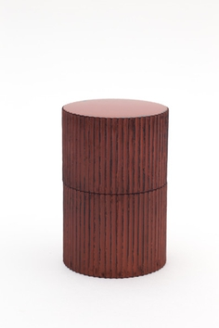 | Jihei Murase 1957-present  Negoro Stripe Tea Caddy, 2019  Lacquer  H3 1/2 x W2 1/2 x L2 1/2 in,  H8 4/5 x W6 x L6 cm  (C19957) | $ 5,700.00
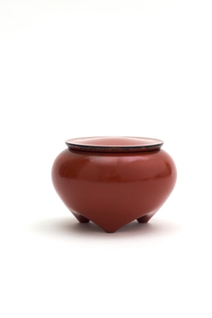 | Jihei Murase 1957-present  Negoro Nuri Tea Caddy, 2019  Lacquer  H2 3/4 x W3 3/4 x L3 3/4 in,  H6 1/2 x W9 3/10 x L9 3/10 cm  (C19959) | $ 5,700.00
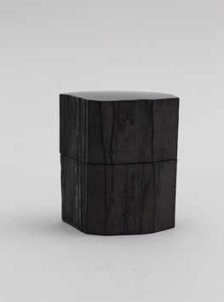 | Jihei Murase 1957-present  Keyaki Tea Caddy, 2017  Lacquer  H3 1/4 x W2 3/4 in,  H8 x W7 1/2 cm  (C19960) | $ 6,000.00
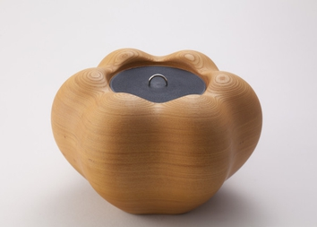 | Jihei Murase 1957-present  Zelkova Pumpkin Water Jar, 2018  Lacquer  H6 3/4 x W10 3/4 x L9 3/4 in,  H16 4/5 x W27 3/10 x L24 3/5 cm  (C20444) | $ 12,000.00
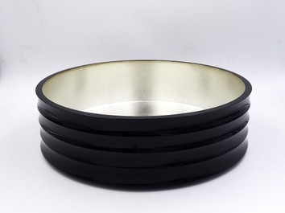 | Jihei Murase 1957-present  Kazura-Oke (Large)  Lacquer  H3 1/2 x W11 15/16 in, H8.9 x W30.3 cm  (C14517AP) | $ 3,000.00
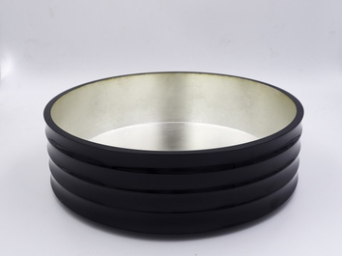 | Jihei Murase 1957-present  Kazura-Oke (Small)  Lacquer  H3 1/4 x W10 11/16 in, H8.3 x W27.2 cm  (C14518AP) | $ 2,800.00
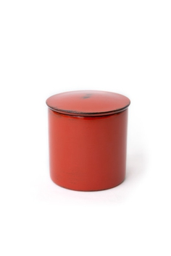 | Jihei Murase 1957-present  根来塗金輪寺, 2019  Lacquer  H2 3/8 x W2 5/8 x D2 5/8 in  H6.1 x W6.6 x D6.6 cm  (C20043P) | $ 3,000.00
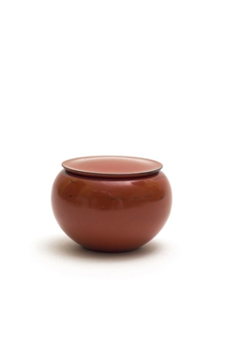 | Jihei Murase 1957-present  根来塗薬器茶器, 2019  Lacquer  H2 1/4 x W3 x D3 in  H5.8 x W7.6 x D7.6 cm  (C20038P) | ¥ 200,000.00
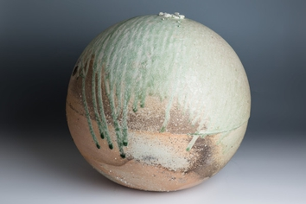 | Shiro Tsujimura 1947-present  Sphere Shaped Jar, Natural glaze  Ceramic  H16 7/8 x W17 3/4 x D17 3/4 in  H43 x W45 x D45 cm  (C12287) | ¥ 1,000,000.00
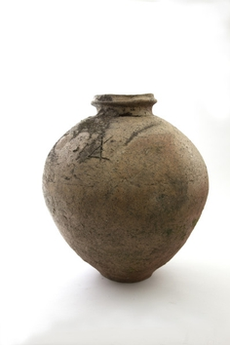 | Shiro Tsujimura 1947-present  Shigaraki pot  Ceramic  H20 1/2 x W18 1/8 x D18 1/8 in  H52 x W46 x D46 cm  (C19729) | ¥ 1,000,000.00
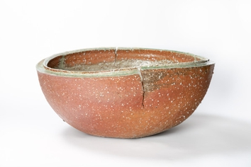 | Kai Tsujimura 1976-Present  Natural glaze pot  Ceramic  H10 1/4 x W23 5/8 x D23 5/8 in  H26 x W60 x D60 cm  (C22859) | ¥ 500,000.00
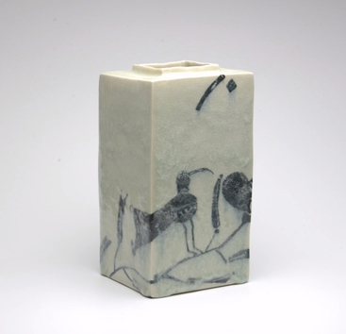 | Shin Fujihira 1922-2012  Bird and Flower , 1980  Ceramic  H9 ½ x W4 ¾ x D4 ¾ in,  H24 x W12 x D12 cm  (C19653NP) | $ 13,500.00
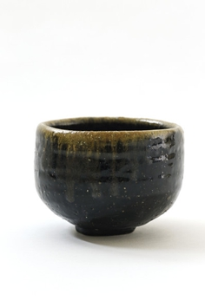 | Jun Isezaki 1947-Present  Black Tea Bowl  Ceramic  H3 9/16 x W4 15/16 in  H9.1 x W12.6 cm  (C19708) | $ 10,000.00
 | Akio Niisato 1977-Present  Black Tea Bowl  Ceramic  H3 1/4 x W4 x D3 1/4 in,  H8.3 x W10.2 x D8.3 cm  (C20845AP) | $ 1,600.00
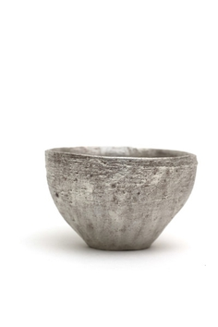 | Yasushi Fujihira 1963-Present  Tea Bowl , 2018  Ceramic  H3 1/2 x W5 1/4 in, H8.6 x W12.8 cm  (C17656) | $ 1,500.00
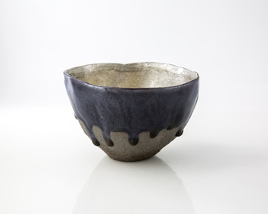 | Yasushi Fujihira 1963-Present  Silver and Black Tea bowl, 2019  Ceramic  H3 2/4 x W4 3/4 x D4 3/4 in  H8.5 x W12.5 x D12.5 cm  (C20651) | $ 1,600.00
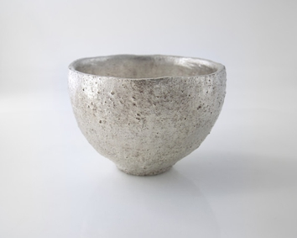 | Yasushi Fujihira 1963-Present  Silver Tea Bowl, 2019  Ceramic  H3 1/4 x W4 2/4 in, H8.2 × W11.4 cm  (C20653) | $ 1,600.00
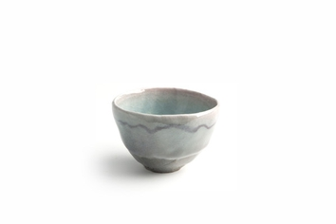 | Yasushi Fujihira 1963-present  「結碗」人から人へ心をつなぐ  Ceramic  H3 1/2 x W4 3/4 x D4 3/4 in  H9 x W12 x D12 cm  (C6757P) | ¥ 100,000.00
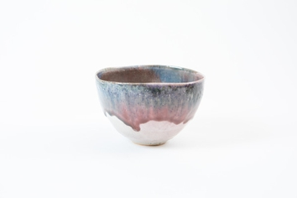 | Yasushi Fujihira  Tea Bowl  Ceramic  H3 1/8 x W5 1/8 x D5 1/8 in  H7.7 x W13 x D12.8cm  (C22322NP) | $ 1,280.00
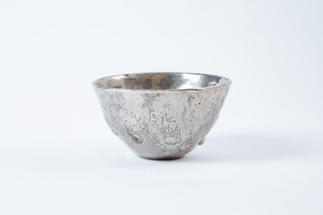 | Yasushi Fujihira  Tea Bowl  Ceramic  H2 3/4 x W4 3/4 x D4 5/8 in  H7 x W12.1 x D11.8cm  (C22325NP) | $ 1,580.00
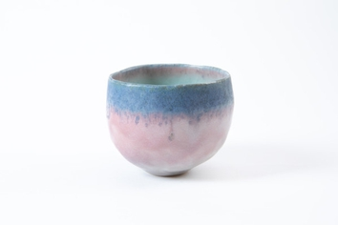 | Yasushi Fujihira  Tea Bowl  Ceramic  H3 7/8 x W4 5/8 x D4 5/8 in  H9.8 x W11.7 x D11.7cm  (C22326NP) | $ 1,360.00
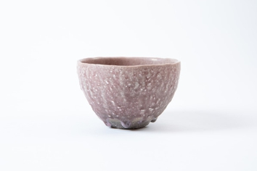 | Yasushi Fujihira  Tea Bowl  Ceramic  H3 1/8 x W4 3/4 x D4 3/4 in  H8 x W12 x D12cm  (C22327NP) | $ 1,300.00
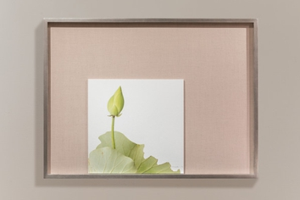 | Takashi Tomo-oka 1971-present  Moon Lotus 1, 2017  Yes  Photography  Photo: H11 1/4 x W11 1/4 in, H28.5 x W28.5 cm  Frame: H18 4/5 x W25 ½ inch, H48 x W65 cm  (A16911) | $ 2,400.00
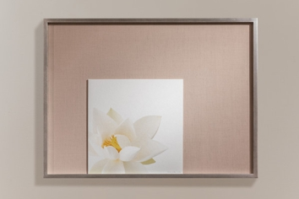 | Takashi Tomo-oka 1971-present  Kuwana White Lotus 3, Kuwana-Hakuren, 2017  Yes  Photography  Photo: H11 1/4 x W11 1/4 in, H28.5 x W28.5 cm  Frame: H18 4/5 x W25 ½ inch, H48 x W65 cm  (A16912) | $ 2,400.00

